ASSIGNMENT :2
1.
In the AWS Management Console, launch two EC2 instances running a simple web server (use Amazon Linux 2 and install httpd or nginx), and verify both are accessible via their public IPs.
ANS :
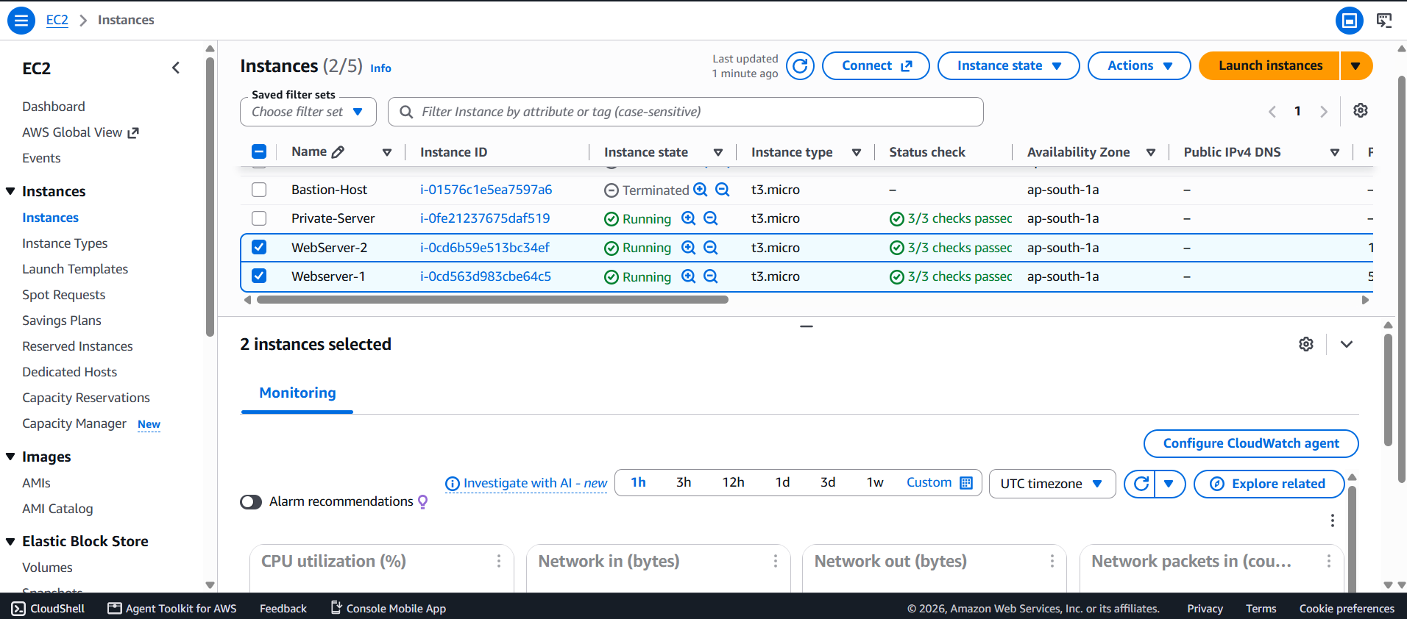
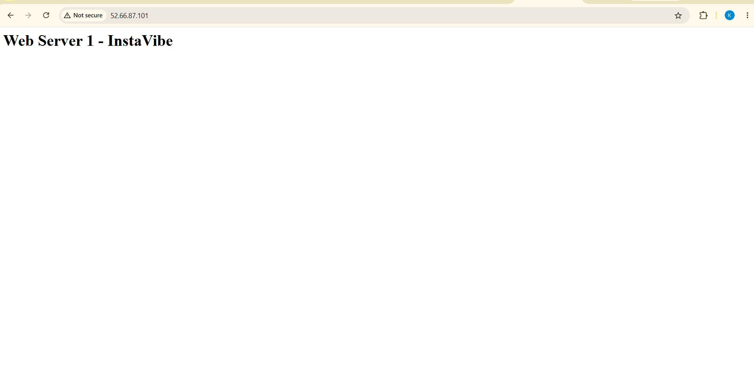

2.
Set up an Application Load Balancer (ALB) in AWS that distributes incoming HTTP traffic across your two EC2 instances, and test by accessing the ALB's DNS name in your browser to see traffic served from both servers.
ANS : Screenshot 1 — Two EC2 instances
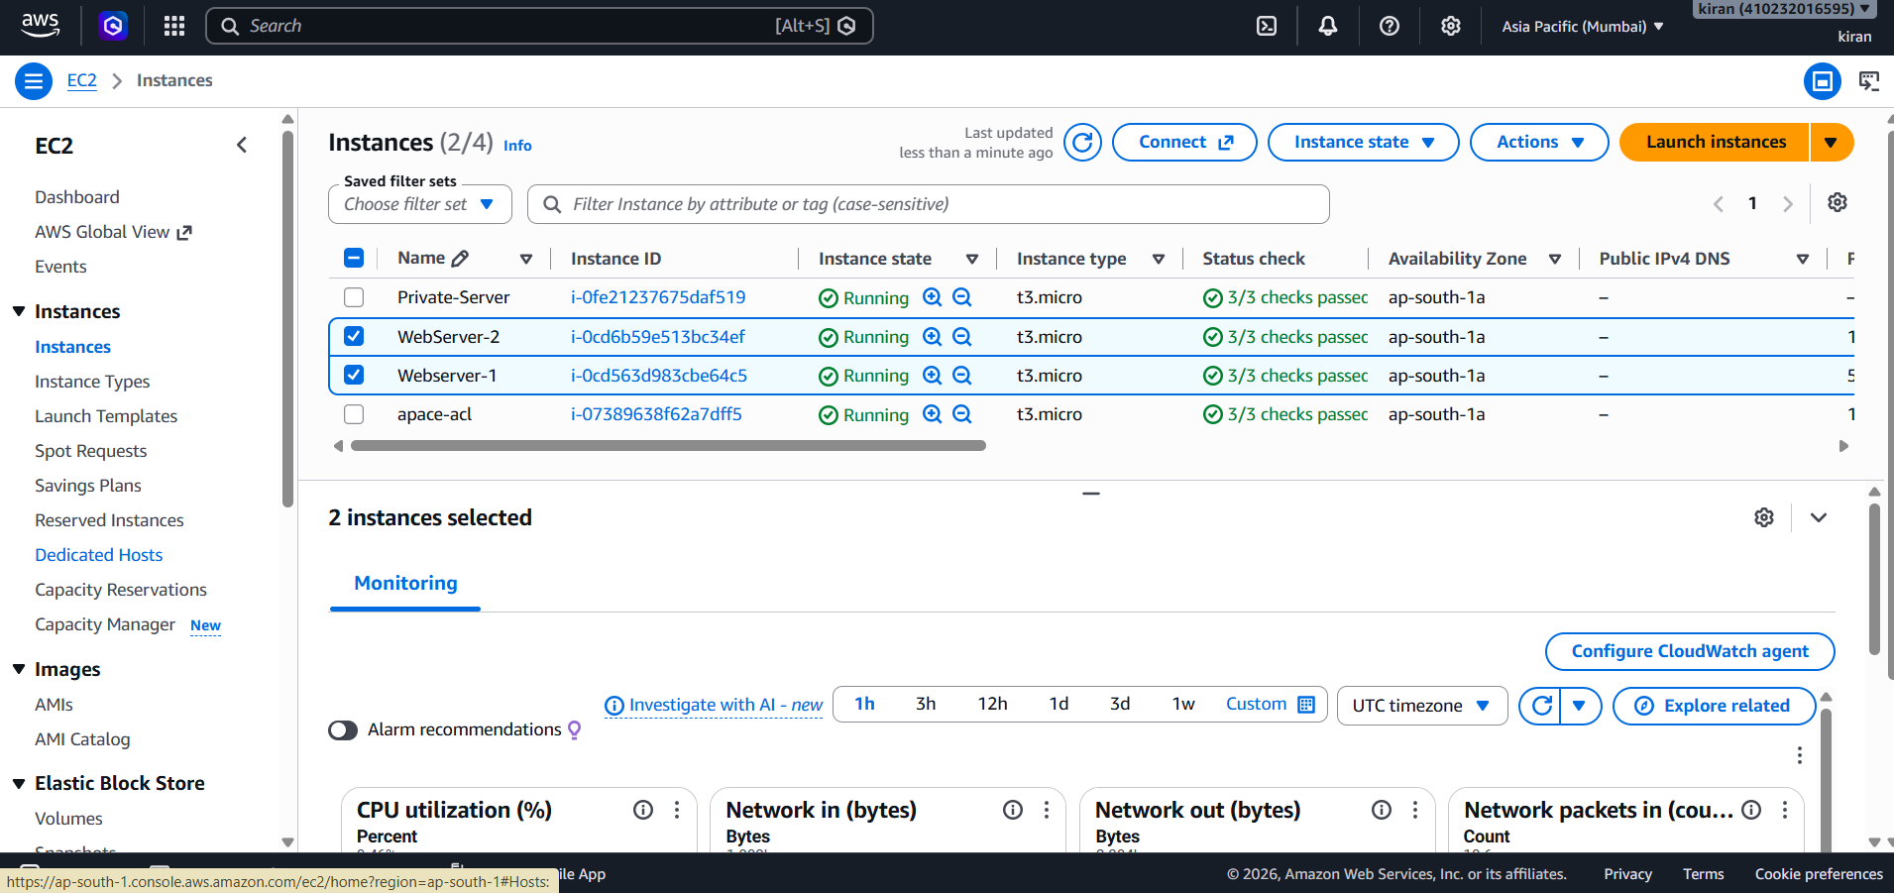
Screenshot 2 — Target Group
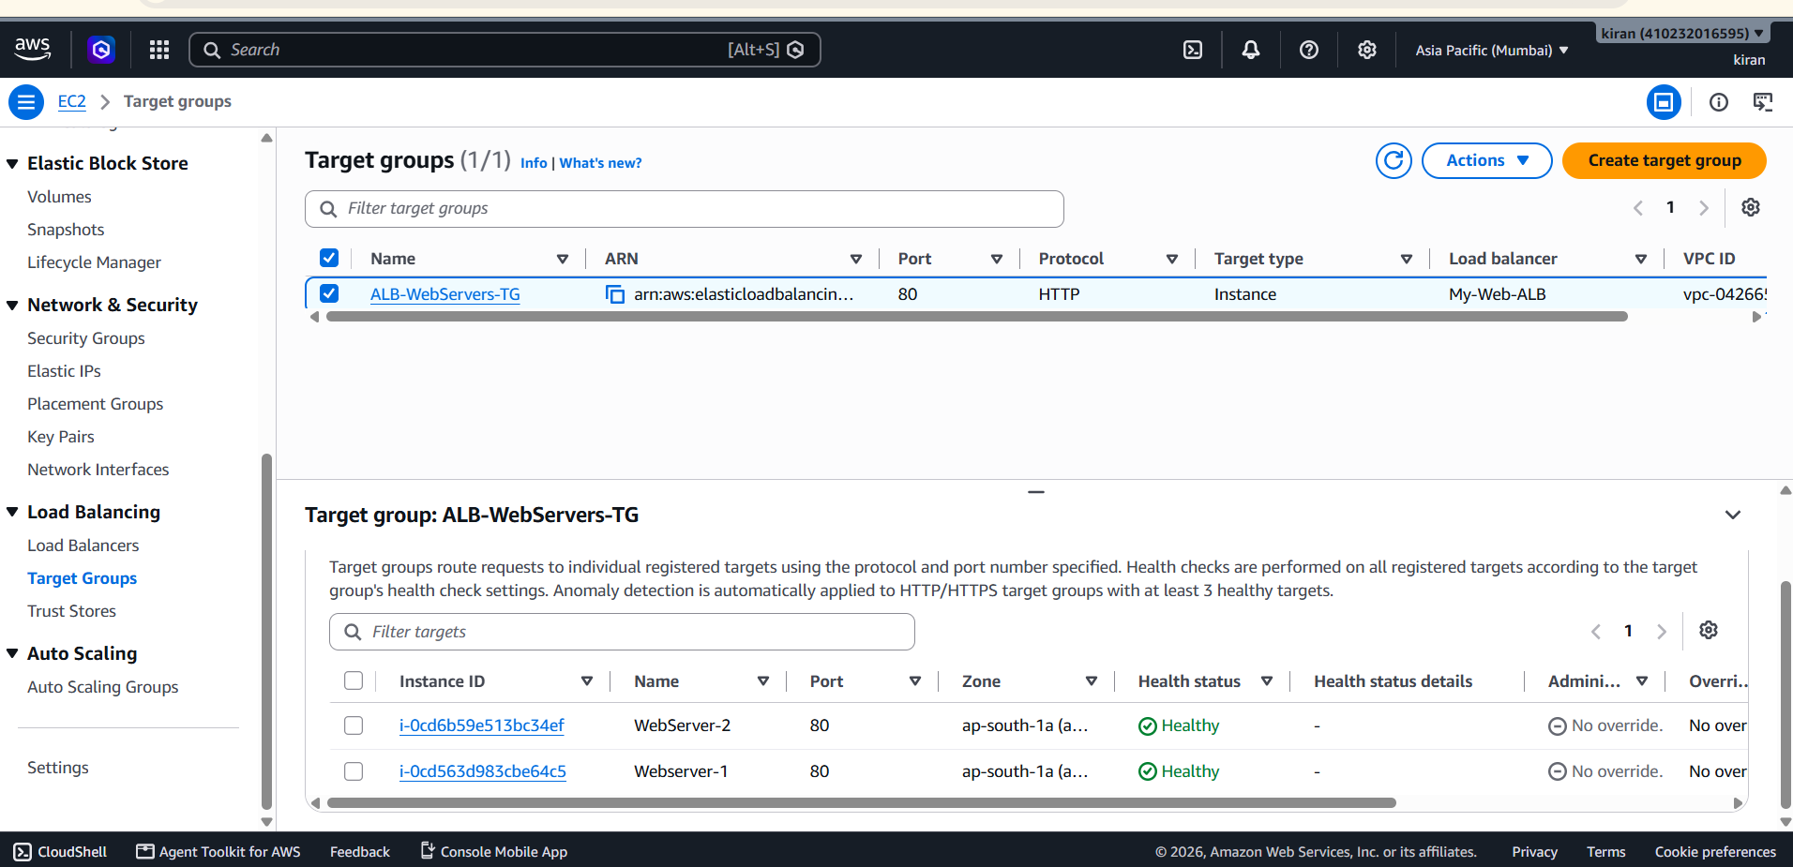
Screenshot 3 — ALB
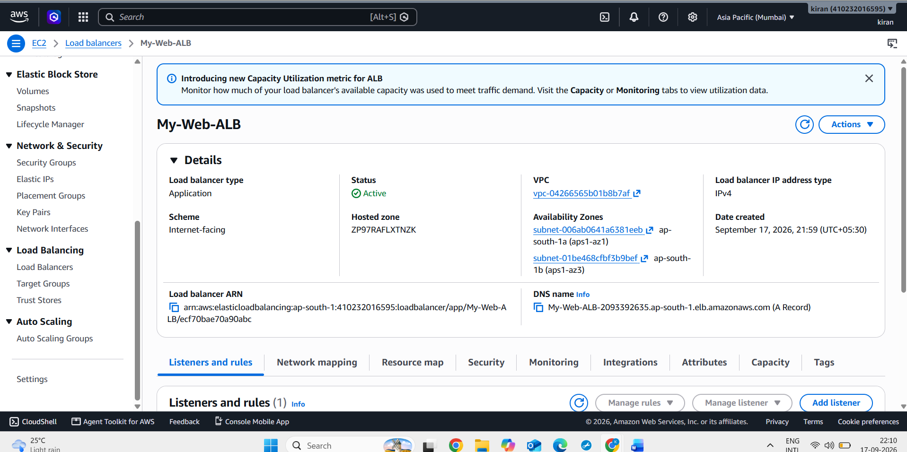
Screenshot 4 — ALB Listener
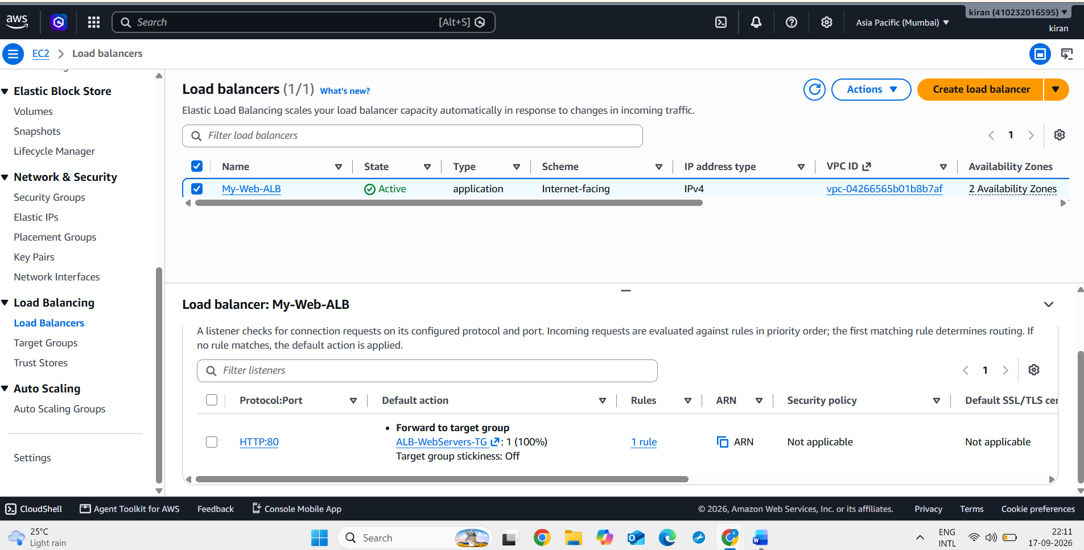
Screenshot 5 — ALB DNS in browser

Screenshot 6 — Second server response


3.
Change the health check settings of your ALB to use a custom path (e.g., /health) and verify that the load balancer only routes traffic to healthy instances.<br><br><em><strong>Hint:</strong> Create a /health endpoint on your web server that returns a 200 OK response.</em>
ANS :Screenshot-1:Connected to the EC2 Instance using SSH and created the custom /health endpoint.
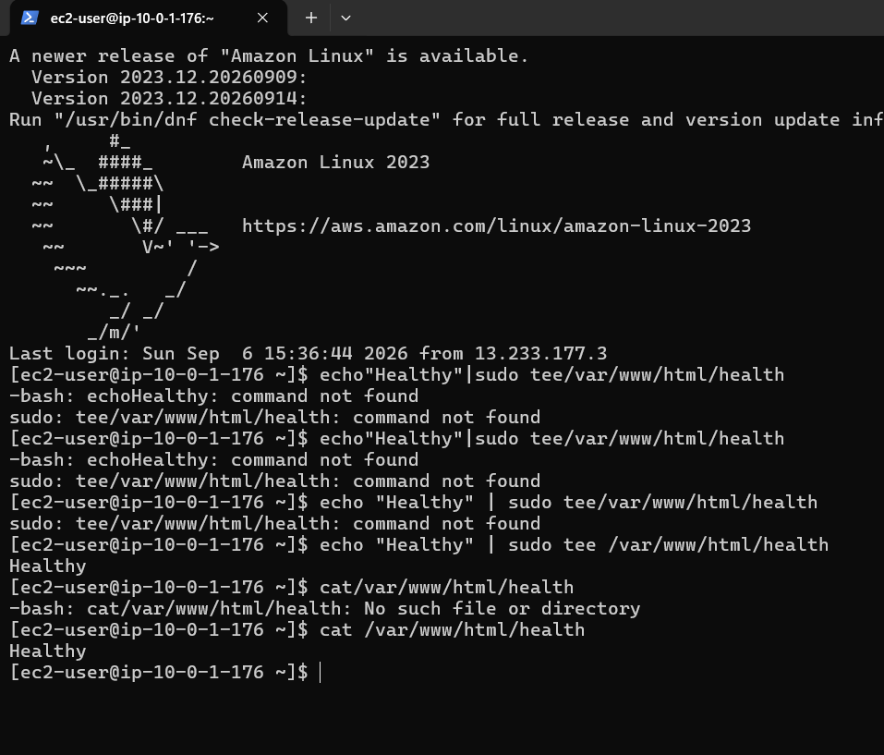
Screenshot 2 :Custom /Health endpoint Successfully configured and verified, showing “Healthy”.

4.
Simulate a server failure by stopping one of your EC2 instances and observe how the ALB handles requests — describe what happens and how this demonstrates high availability.
ANS : Screenshot : Before Failure
Screenshot : After Failure
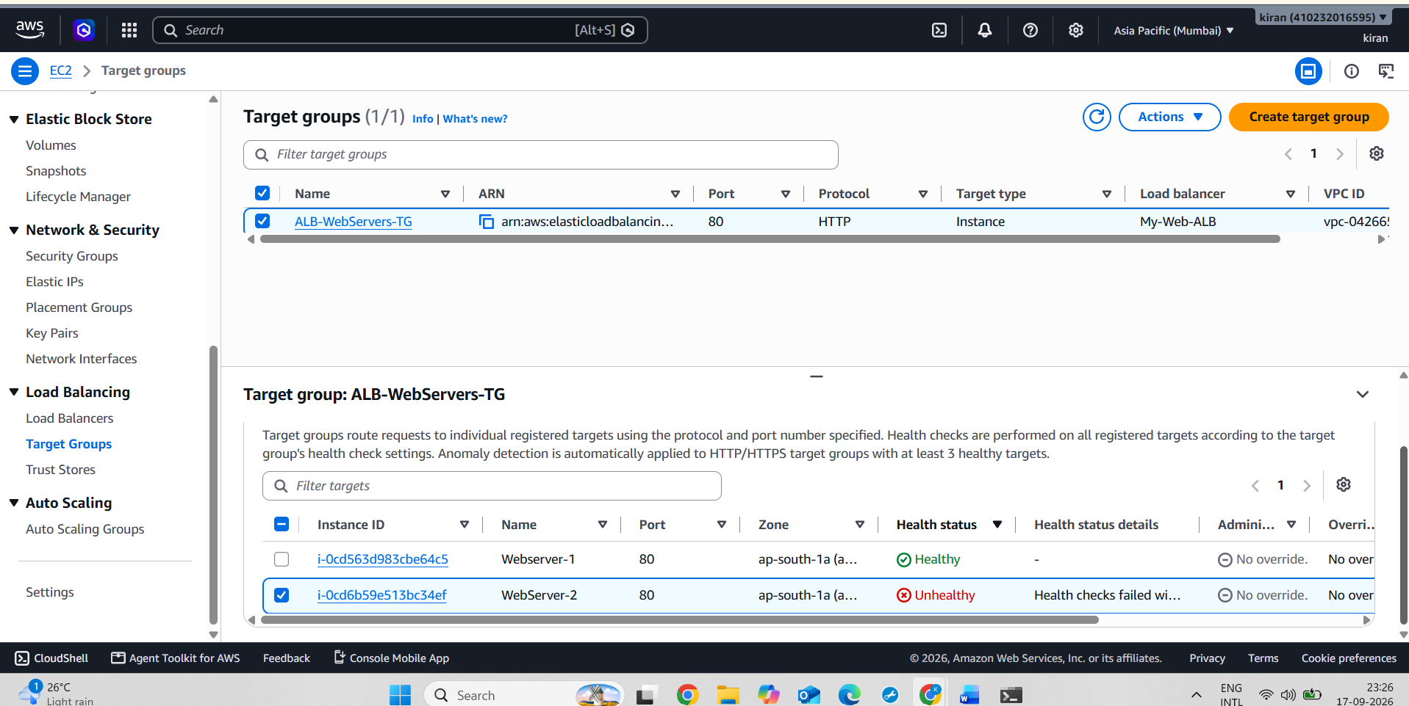

5.
Compare Application Load Balancer, Network Load Balancer, and Classic Load Balancer in a table with at least 3 points each, focusing on supported protocols, use cases, and features.
ANS :
Feature | Application Load Balancer (ALB) | Network Load Balancer (NLB) | Classic Load Balancer (CLB)
OSI Layer | Layer 7 – Application layer | Layer 4 – Transport layer | Supports Layer 4 and Layer 7-style traffic
Supported Protocols | HTTP, HTTPS; supports HTTP/2 and WebSockets | TCP, TLS, UDP, TCP_UDP, QUIC and TCP_QUIC | HTTP, HTTPS, TCP and SSL
Main Use Case | Web applications, websites, APIs and microservices | High-performance applications requiring TCP/UDP/TLS and very high throughput | Older applications that were built using the original ELB architecture
Routing | Content-based routing using URL path, host, headers, query parameters, etc. | Connection/flow-based routing | Basic routing to registered EC2 instances
Key Features | Path-based and host-based routing, redirects, authentication, Lambda targets and container support | Static IP addresses, Elastic IP support, very high performance and preservation of client IP | Simple load balancing and application-generated cookie-based sticky sessions
Target Types | EC2 instances, IP addresses, containers and Lambda functions | EC2 instances, IP addresses and other supported target types | Primarily EC2 instances
Health Checks | Performs health checks on target groups | Performs health checks on target groups | Detects unhealthy EC2 instances and stops sending traffic to them
Best Suited For | Modern web applications and HTTP/HTTPS services | Real-time, high-performance and non-HTTP applications | Legacy applications already using Classic Load Balancer

